COGNIZANCE

TASK-5(I)

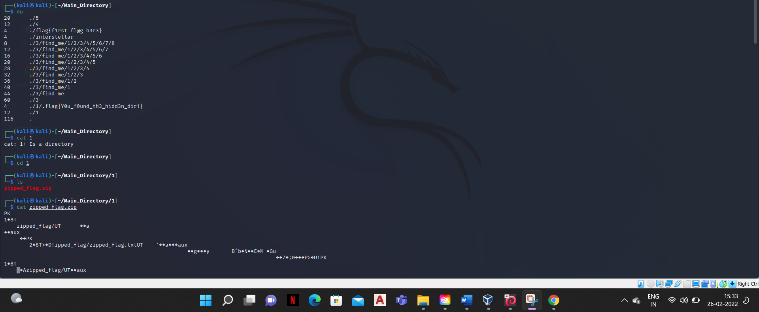

The 1st flag is flag{first_fl@g_h3r3}

The 2nd flag is flag{Y0u_found_th3_hidd3n_dir!}

cat

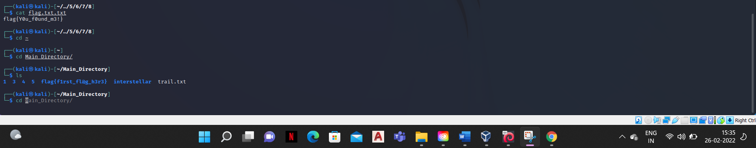

The 3rd flag is flag{Y0u_f0und_m3!}

Cat 1.txt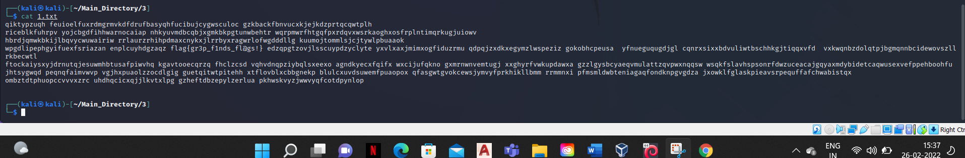

The 4th flag is flag{gr3p_f1nds_fl@gs!}

